**IEOR 4577 Homework 5**

Ziwei Li ZL2853

Ying Zhu YZ3737

Yuxuan Mao YM2759

Step1: Crete Sagemaker Model from model.tar.gz

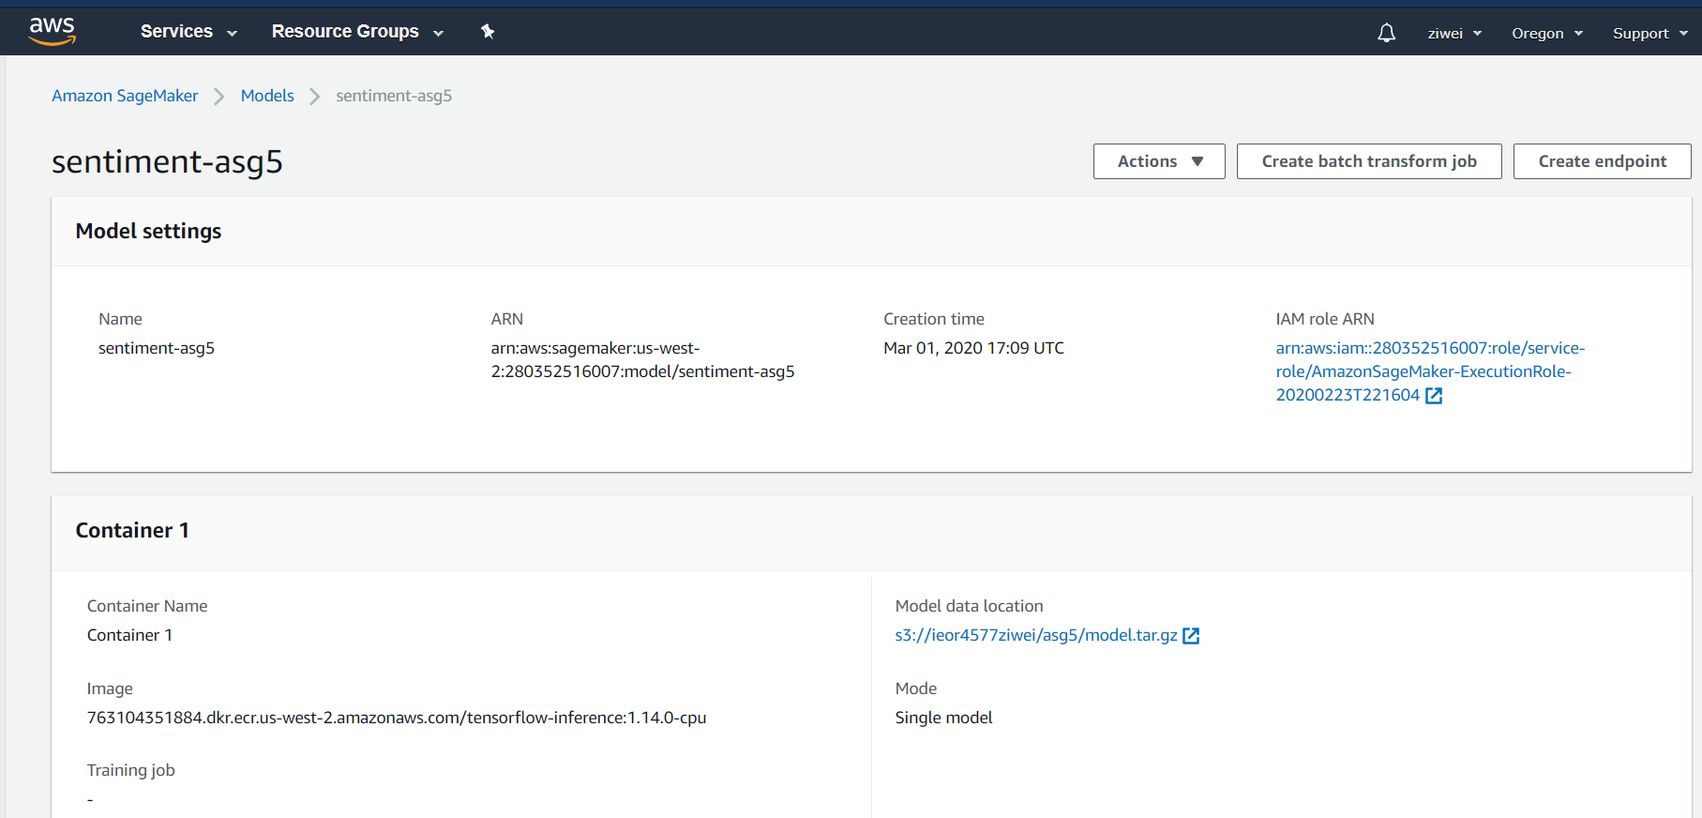

Create Endpoint Configuration

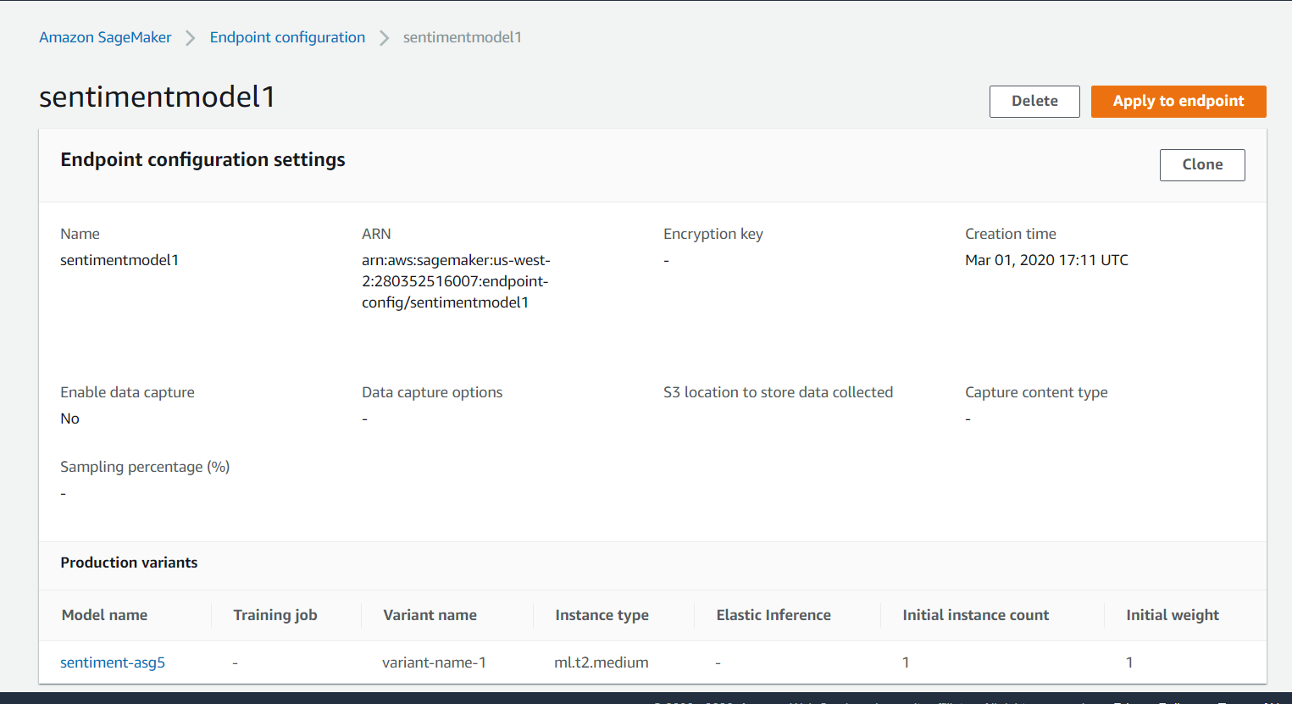

Create Endpoint

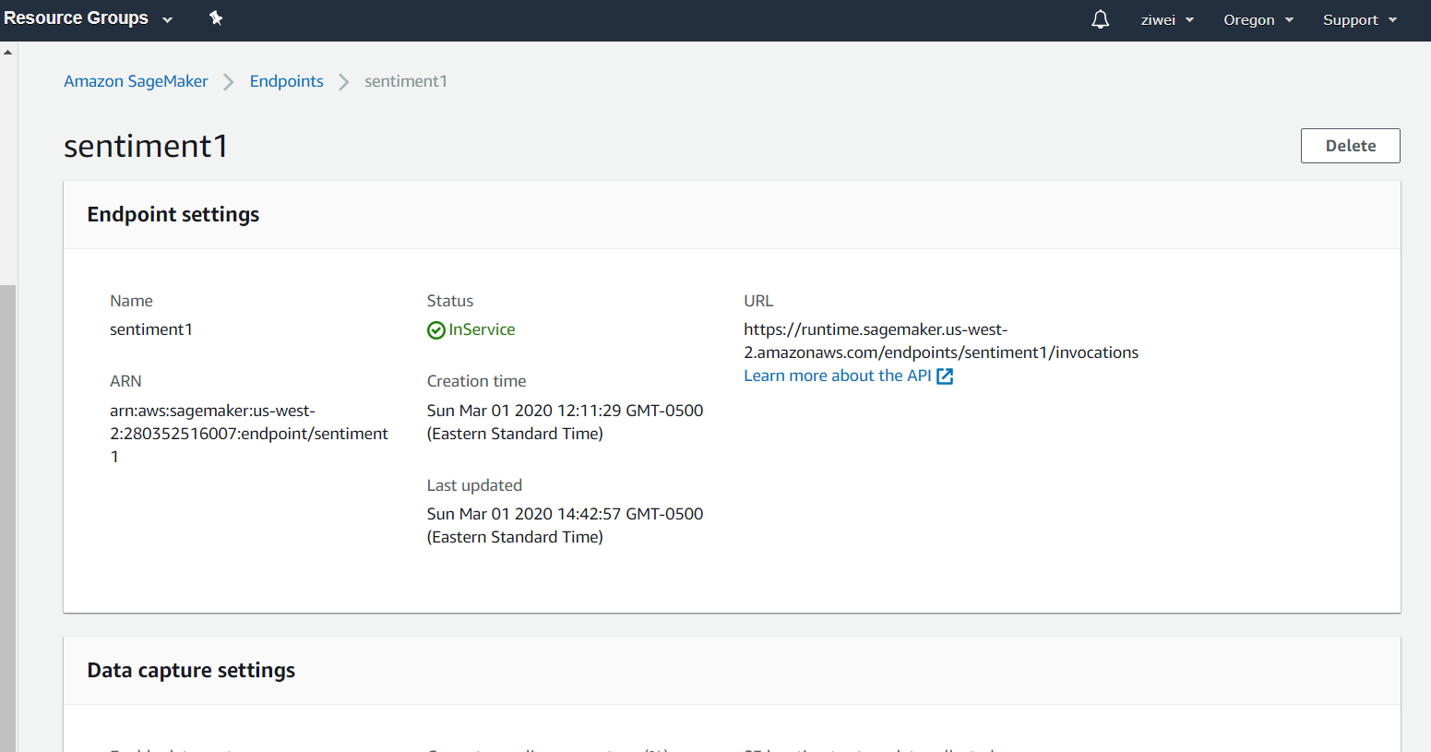

Step2&3: Create Lambda function & Add payload information

See attached code in Zip file

Test result at Lambda UI:

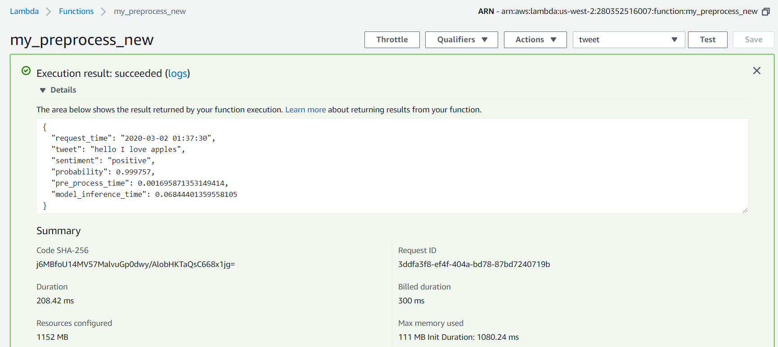

Step4: Deploy REST API

Create ‘predict’ resource and POST method:

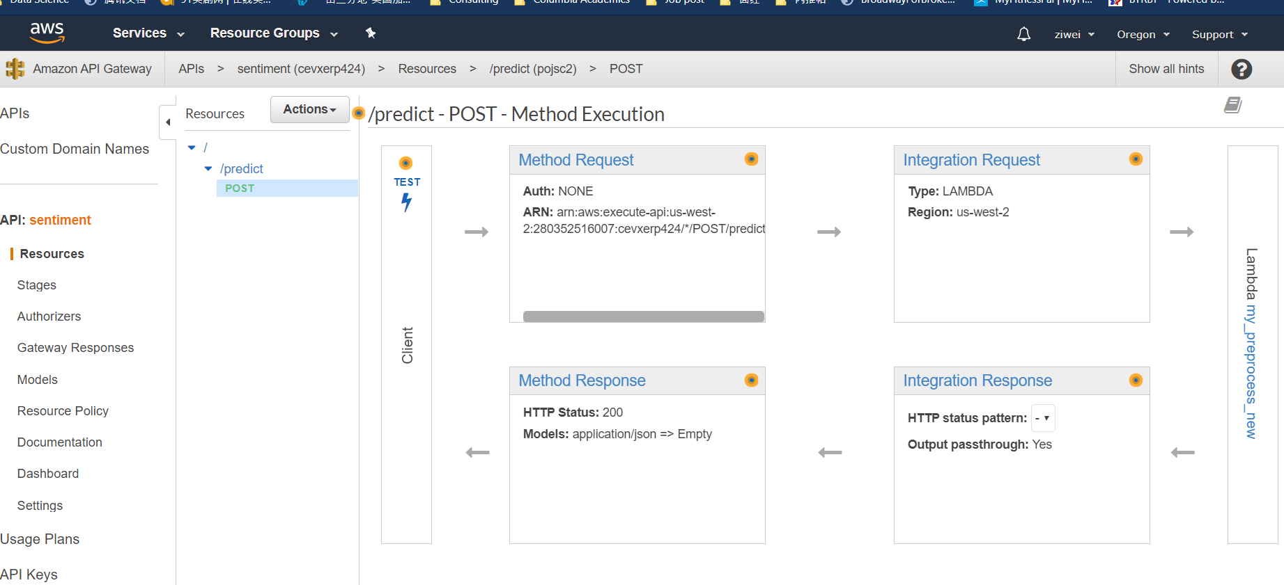

Test API on AWS UI

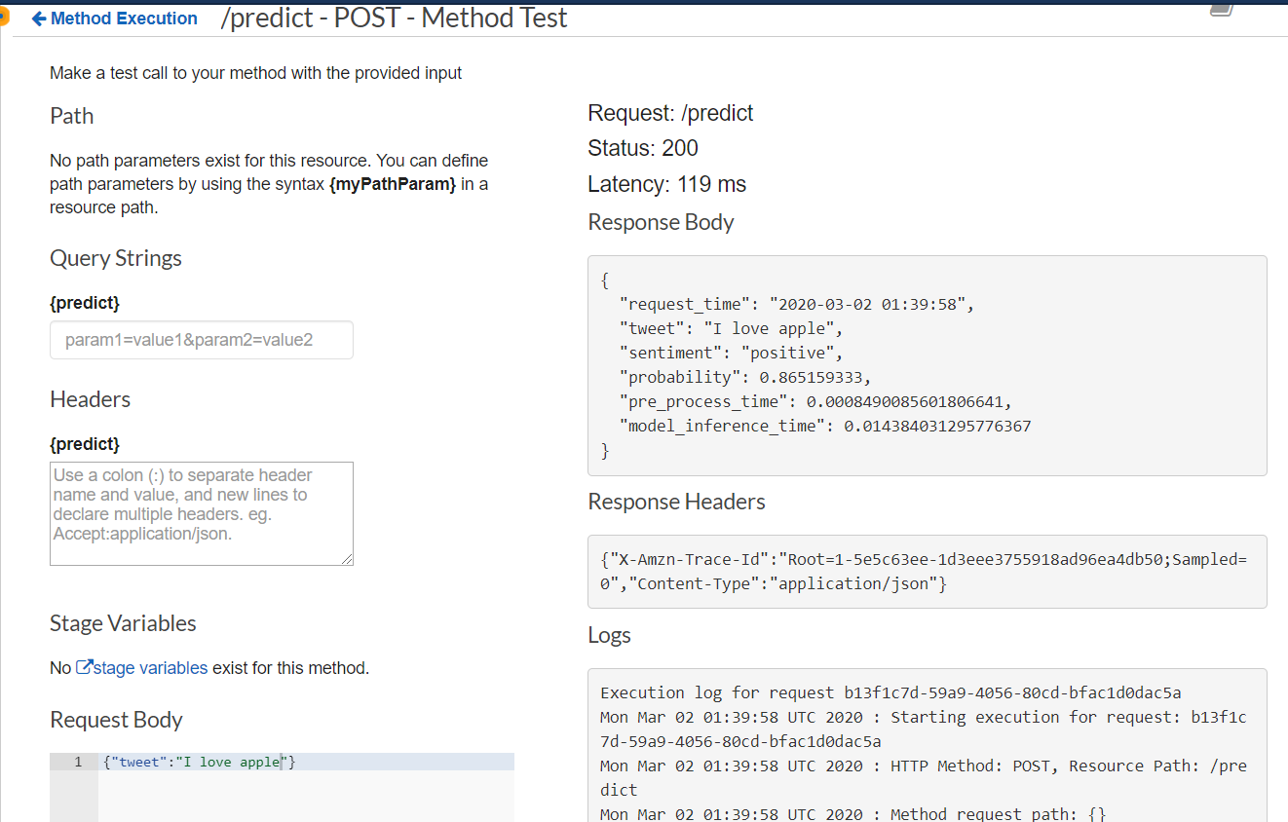

Deploy and test with terminal

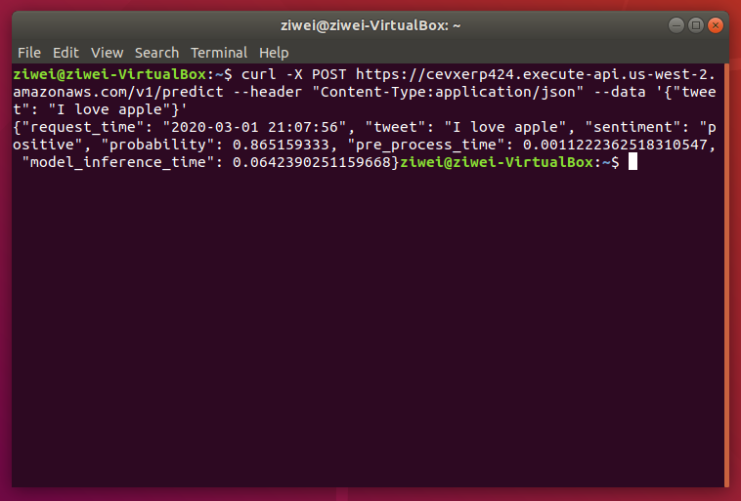

Check Bucket “Sentimentlog” for all API call

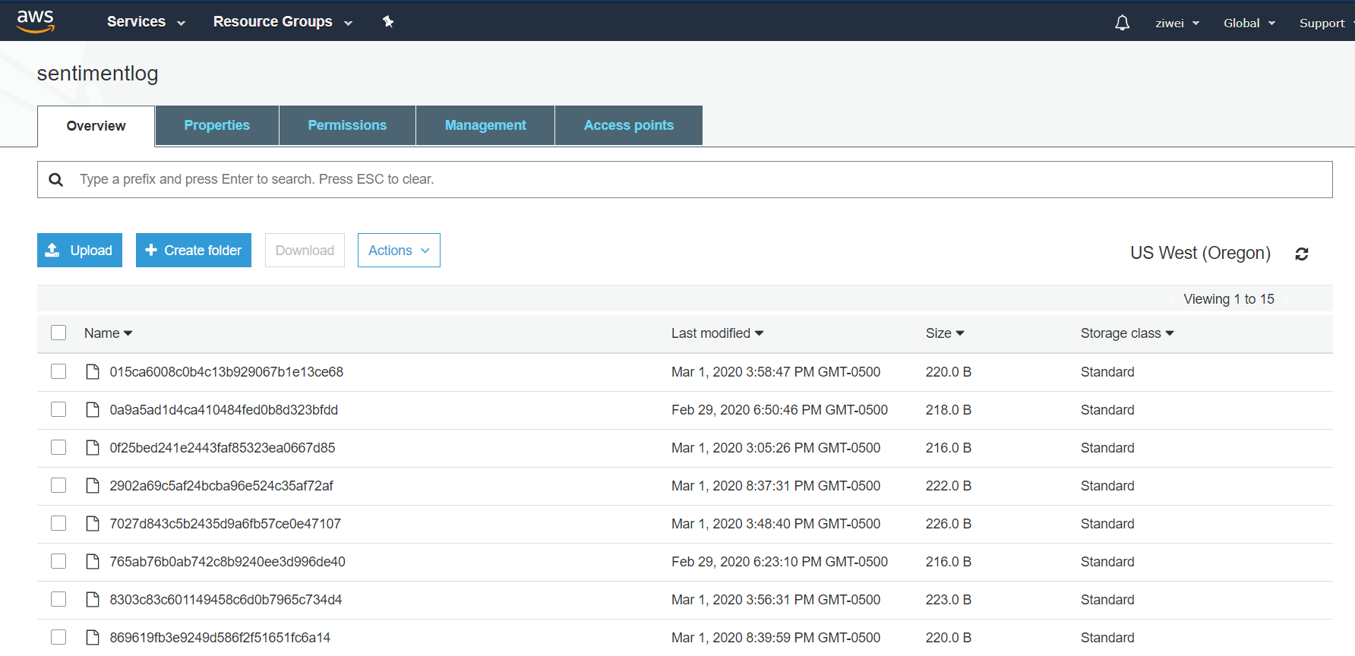

Sample Json:

